**Geographic Power Distribution Model:**

**Where the Power Lies**

**AN INTRODUCTION TO UNITARY, FEDERAL AND CONFEDERAL SYSTEMS OF GOVERNMENT**

**AUTHORITY – CENTRALIZED OR DECENTRALIZED?**

Every state has multiple levels of authority, though the geographic distribution of power varies widely. Some systems centralize authority, while others decentralize it.

**UNITARY, FEDERAL AND…CONFEDERAL?**

A **unitary system** is one that concentrates all policymaking powers in one central geographic place; a **confederal system** spreads the power among many sub-units (such as states), and has a weak central government. A **federal system** divides the power between the central government and the sub-units. All political systems fall on a continuum from the most concentrated, centralized amount of power to the least. Uni­tary governments may be placed on the left side, according to the degree of concentration; confederal governments are placed to the right; and federal governments fall in between.



**CONFEDERAL STATES**

The United States under its earliest constitution, the Articles of Confederation, was confederal. Ultimate power rested with the states. The central government had authority over foreign affairs and defense but depended on financial and other support from the states.

**WEAK**

**National / Confederal Government**



**Citizens**

**Direction of Power**

**STRONG**

**State Government**

**STRONG**

**State Government**

**STRONG**

**State Government**



**Elections**

**FEDERAL STATES**

Under the Constitution of 1787, the U.S. govern­ment changed from confederal to federal, which is to say that both central and state governments had sepa­rate spheres of authority and the means to implement their power. Today, the United States, Germany, Russia, India, Nigeria, Mexico, Brazil, and most importantly **CANADA** are **federal systems** in which central and local units each have autonomy in particular spheres of public policy. These policy areas and powers are, however, divided among central and local units in varying ways.

**National / Federal Government**



**Citizens**

**State Government**

**State Government**

**State Government**



**Elections**

**Directions of Power**

**UNITARY STATES**

Britain, France, China, Japan, and Iran are unitary systems with power and authority concentrated in the central government. Regional and local units have only those powers specif­ically delegated to them by the central government, which may change or withdraw these powers at will.

Most of the world's states are unitary. In fact, only eighteen states are federal, or fewer than one in ten. Although the federal states are relatively few in num­ber, they tend to be large and politically important. Thus, federal states account for more than one-third of the world's population and 41 percent of its land area. In general, the larger and the more diverse a state is, the more likely it is to be federal.

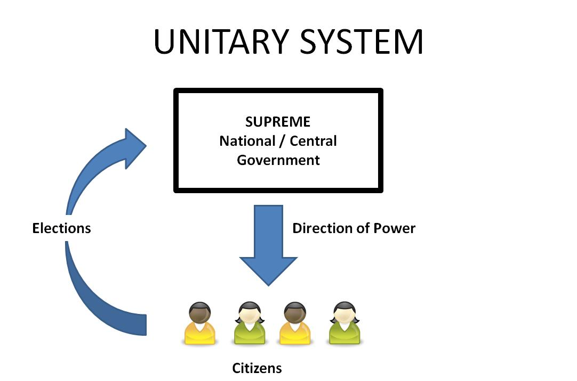

**THE PROS and CONS of EACH SYSTEM**

Federalism is commonly thought to have several advantages. In culturally divided societies, it may help protect ethnic, linguistic, or religious minorities, par­ticularly if they are geographically concentrated. It may serve as a check on overly ambitious rulers and thus protect markets and citizen freedoms. Moreover, feder­alism may allow subunits (such as states) to experiment with different policy programs. Governments may thus learn from the experiences of others. In addition, citi­zens may be free to "vote with their feet" and choose the policy environment that best fits their preferences.

While federalism promotes choice and diversity, however, it does so at the expense of equality. Federalism allows local governments to pursue differ­ent policies. One implication is that citizens may get systematically different treatments and benefits from different local governments. Unitary governments may also be in a better position to redistribute resources from richer regions to poorer regions, if that is desirable.

**STRUCTURE vs. PRACTICE**

In comparing confederal, federal, and unitary sys­tems, we must distinguish between formal and actual distributions of power. In unitary systems, in spite of the formal concentration of authority at the center, regional and local units may acquire power that the central government rarely challenges. In federal sys­tems, centralized party control may overcome apparent regional autonomy. Thus, the real differences between federal and unitary systems may be considerably less significant than their formal arrangements suggest.